Haircut on HackTheBox

Started off with some nmap scans:

Quick google search shows that this version of nginx is vulnerable to CVE-2021-23017.

A browse + ffuf of the website finds nothing of value other than an image an a forbidden uploads folder.

Decided to use the CVE exploit using <https://github.com/M507/CVE-2021-23017-PoC/blob/main/README.md>, but did not work.

Decided to run dirbuster just as a sanity check, and found some more files: 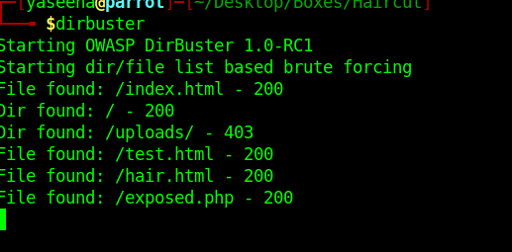

Tweaking the values a little got me to this:

The home page could be loaded from an outside IP address rather than the localhost.

So I created a simple html page and hosted it on a python server and uploaded it.

Works!

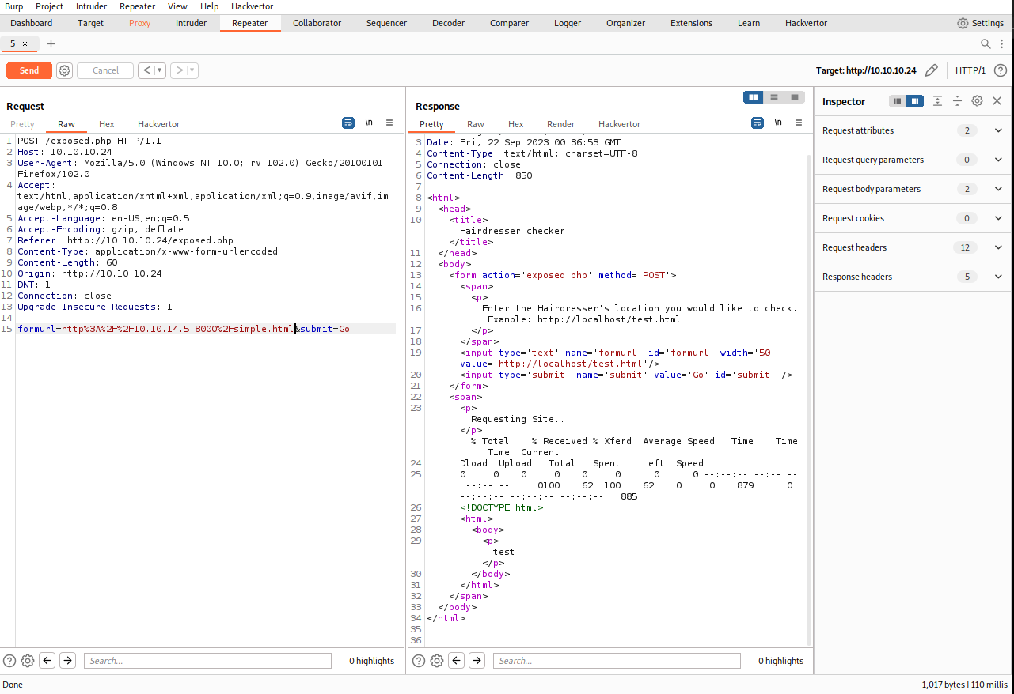

Page had several php pages running, so decided to test it with php:

Works, but seems to interpret it as html.

Decided to upload an echo ‘test’ to see what would happen:

Wasn’t sure if it was being rendered interpreted or not, so I decided I would put in a time delay to see if it was being executed, and the time delay and inspect-elementing the actual website confirmed that everything was being commented out.

Checked the curl page and found the -o flag might be useful, so decided to write the output to the /uploads folder:

Works AND it slept for 5 seconds!!!! We have execution.

Uploaded a webshell:

Shell!!!!

User flag:

Maria seems to be the only current user on the device after analysing /etc/passwd.

Downloaded linpeas because I can’t find any obvious way to priv esc:

Looks interesting…

A google search finds a priv esc vulnerability in it.

Manually compile the C code and uploading it didn’t work ☹

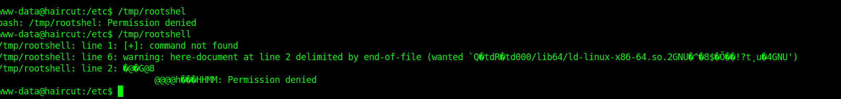

Little nudge from Khalid led me to PwnKit: <https://github.com/ly4k/PwnKit/blob/main/README.md>

WORKED!

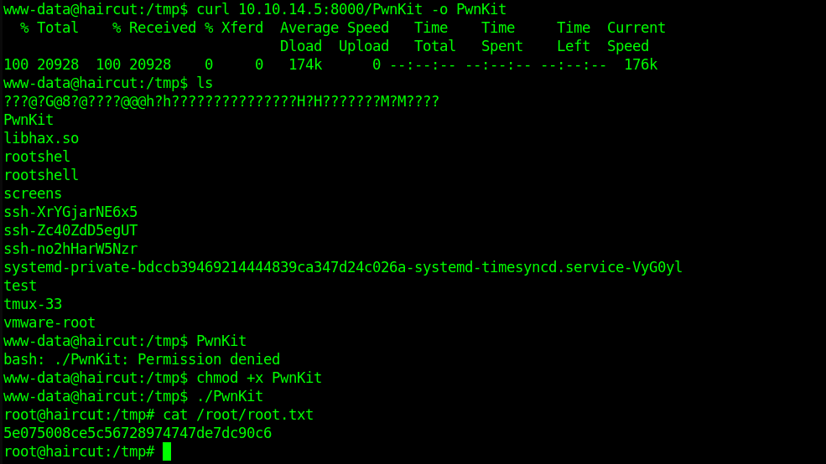

ROOOOOOOOOOOOOOOT!!!